

BPM – BUSM4610 - Assignment 2 Project Proposal

Due: 29th September 2023

**Team:** Group 2; **Class**: Wednesday, 6:30 pm

Abhishek Sharma – s3994650 – (s3994650@student.rmit.edu.au)

Wint Wah Shein – s3873198 (s3873198@student.rmit.edu.au)

Nikunj Gupta – s3960231 ([s4027333@student.rmit.edu.au](mailto:s4027333@student.rmit.edu.au))

Achutha Kumar s3998959 ([s3998959@student.rmit.edu.au](mailto:s3998959@student.rmit.edu.au))

Bhargava Gajji s3992201 ([s3992201@student.rmit.edu.au](mailto:s3992201@student.rmit.edu.au))

**Tutor:** Maurice Abi-Raad

Word count = 2,969/5,000

Total word count including cover letter, tables, figures, and references = 5,234

**"The Next Step towards the Future: A Visionary Project For SVP”**

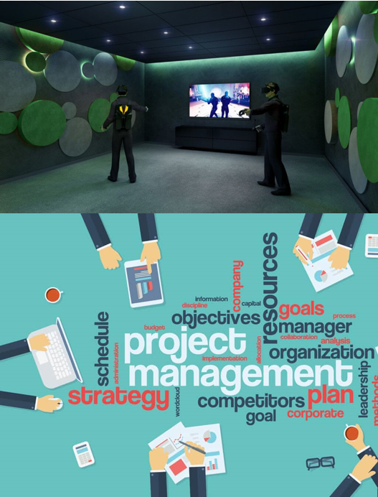

# Cover Letter

**"The Next Step towards the Future: A Visionary Project For SVP”**

September 29, 2023

Dear SVG group,

We are excited about having the opportunity to submit a proposal to assist your firm in upgrading VR gaming centre In our related business proposal, we provide how we can assist your company in transitioning from simply attempting to acquire SVG’s clients of all ages and include families, couples, individuals, school groups and corporate clients in enjoying one of leading VR centre with upgraded items.

The team will be carrying out the project; members include Abhishek Sharma, Wint Wah Shein, Nikunj Gupta, Achutha Kumar, and Bhargava Gajji. Abhishek excels at developing a cohesive and acceptable project strategy. Wint is an expert in picking the most cost-effective equipment for the organization. As a manager, Nikunj may guarantee an acceptable allocation of resources and seamless completion of the project. In the meantime, Bhargava excels at managing expenses and maintaining costs within a realistic range so that either the team or SVP can benefit from the most cost-effective solutions. Furthermore, Achutha has years of expertise in handling risks, which will ensure the project's successful completion. In the proposal, our team will be accountable for offering an SVP game Centre designed to give customers an immersive gaming experience using virtual reality headsets and controllers, having upgraded VR spaces with a soundproofing panel, and having an upgraded home theatre system. The project is set to begin on March 1, 2024, and finish on May 21, 2024, with a duration of **58** days. The total cost required for this project is **$90,971**. Team members have their own area of specialty and have worked on several large and difficult office projects. Because of our extensive knowledge in the area, we can easily troubleshoot any potential problems or dangers that may arise during the project

We believe that the above qualities and experiences would make us a valuable collaborator with your company. We look forward to working with SVP, and please let us know if there are any further questions about the enclosed proposal.

Sincerely,

Abhishek Sharma, Wint Wah Shein, Nikunj Gupta, Achutha Kumar, Bhargava Gajji.

**Table of Contents**

Cover Letter 3

Charter 5

1.Introduction 6

2. Scope 6

3. Deliverables 8

4. Schedule 15

5. WBS Dictionary 23

6. Resources 25

7.Cost 27

8.Risk 28

Risk response matrix 32

9. Stakeholders 33

References 38

# Charter

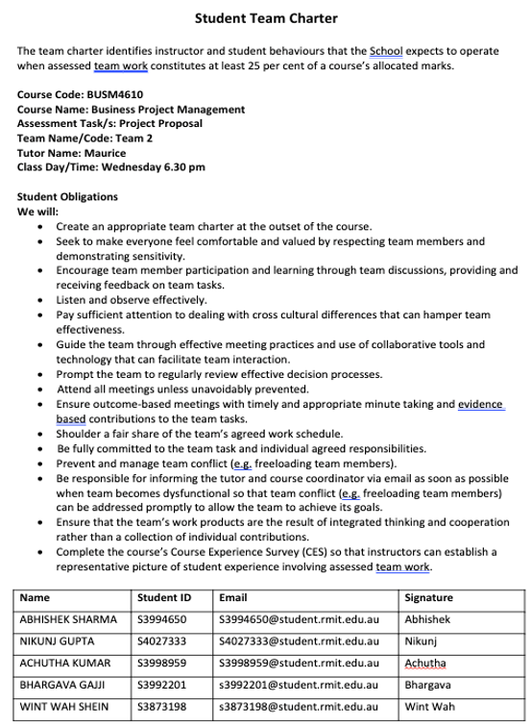

# 1.Introduction

In the following proposal, the SVG VR gaming spaces will be upgraded by the list of supply items requested by the client, Supercharged VR game Center. The proposal includes the project scope description, schedule, deliverables, cost predictions, resource planning, as well as risks and planned remedies throughout project implementation and linked stakeholders.

# 2. Scope

The project scope outlines the boundaries, objectives, and constraints of the project. In this case, the project scope involves upgrading and enhancing Supercharged VR Games' facilities and equipment to improve the customer experience, address noise complaints, and meet specific requirements.

**Objective:** To set up a functional sound-proofing VR game space with the highest efficiency at the SVG, a virtual reality gaming Center that is designed to give customers an immersive gaming experience using upgraded commercial-grade virtual reality headsets and controllers covered by a comprehensive manufacturer's warranty, and to offer a multi-functional interactive customer waiting room with a home theatre system at a total cost **$90,971** during the period between March 1, 2024 and May 21, 2024.

**Description**: A gaming Center that will upgrade soundproofing in three rooms that are 170 sq ft with a celling 2 ft high each includes 27 commercial-grade VR headsets and controllers, installing eco-friendly sound panels. Secondly, when renovating an interactive customer waiting room with an 85-inch 8K Ultra HD home theatre system, the sound speaker should be 5.1 surround wireless.

**Justification**: The current VR spaces in SVG Centre presently have a weaker soundproofing system, as neighboring tenants have complained about the noise. To address this issue and ensure customer satisfaction in a competitive market, we have undertaken a comprehensive renovation. Our upgraded VR soundproofing rooms feature high-functioning headsets and sound panels, eliminating noise disturbances and enhancing the overall gaming experience.

In addition to the improved soundproofing, we have transformed the customer waiting room into a state-of-the-art space. Equipped with an ultra-HD home theatre system, it offers a superior environment that caters to the unique preferences of each client before their 30-minute game session. We have collaborated with a team of experts, including installation technicians, design engineers, electricians, and audio engineers, to ensure the flawless execution of this project. This not only guarantees correct installation but also reduces waiting room stress, creating a pleasant and immersive ambiance with the addition of a 5.1 surround wireless sound system, all in line with the highest standards for waiting room areas.

**Technical specifications:**

* Every device and the overall environment configuration must meet Australian laws and norms.
* The headset and controller must comply with sophisticated features and be commercial grade, with motion tracking and high-resolution, and have a comprehensive manufacturer's warranty.
* The sound panel is from reputable manufacturers in 3 VR rooms and is environmentally friendly, recyclable, and made of natural material.
* The 85-inch flat-panel HD TV and 5.1 sound speaker system are from well-known brands that will be included in creating a home theatre system.
* It is necessary to provide video content, digital operating guidelines, and technological troubleshooting assistance help.
* Each piece of equipment includes a warranty.

**Restrictions and exclusions:**

* The tangible equipment, such as 27 headsets and controllers, a TV, and a wireless speaker, is provided by the supplier.
* When sound panels are delivered, the necessary installation by the labour will be done.
* The team will offer 5 business days' advance notice of the products and services' delivery date.
* Training sessions occur when products are available and ready after being set up at the Center.
* If the products do not meet the standards, the SVP shall give an email notification to our team within 5 business days.
* The team will be penalized for pushing back the delivery date.
* The project will begin once the client has paid 30% of the total contract amount.
* The project must be finished before June 1, 2024.

# 3. Deliverables

|  |  |
| --- | --- |
| **Deliverable Items** | **Description** |
| **Tangible** |  |
| Headset and Controller | VIVE Pro 2 Kit Headset with Each headset includes specifications such as price, resolution, field of view, refresh rate, tracking, audio, microphone, processor, storage, connections, ergonomics, IPD, controller, battery, and shipping details. |
| Sound Panel | Woven Image Longitude Acoustic Panels each one includes specifications such as price, size, thickness, composition, sustainability, acoustic performance, installation, fire ratings, environmental certifications, maintenance, customization, and additional information. |
| Flat Panel TV 85 inch | Samsung QN800B 85" Ultra HD 8K TV including specifications such as screen technology, screen size, HD type, lighting technology, local dimming, wide colour gamut, recommended viewing distance, audio, connectivity, and shipping details. |
| Wireless Speaker | Samsung HW-Q800C/XY 5.1.2ch Dolby Atmos Soundbar, including specifications such as product name, model, color, channels, sound modes, connectivity, voice assistant compatibility, weight, included items, manufacturer's warranty, and key features. |
| **Intangible** |  |
| Environment Setting | After Installing everything, the team will change the layout, and create a new upgraded environment. |
| Troubleshooting Integration | Creating the guidelines for troubleshooting common issues where the team makes instructional videos for using the gaming equipment and home theatre system. The team will also create a single PDF manual explaining how to use the headsets, controllers, TV, and speaker system. Plus the sound panel company will give maintenance pdf files for sound panels. |
| Training Session | The Training Session includes organising training for the Facility Manager and VR hosts. Gather feedback from the host and address any concerns |
| Installation of equipment | The installation of equipment includes connecting the hardware, and installing the headsets, controllers, and home theatre system to the current SVG system. |
| Installation of sound panels | The installation team of the sound panel company will come and measure the VR spaces and set them up in three VR rooms. |

*Table 1: Deliverables for SVP*

**Sound panel companies**

Acoustic Panel and Comparison Report of Three Brands

1. Autex Cube Acoustic Panels

2. Woven Image Longitude Acoustic Panels

3. Cube™ Acoustic Panels

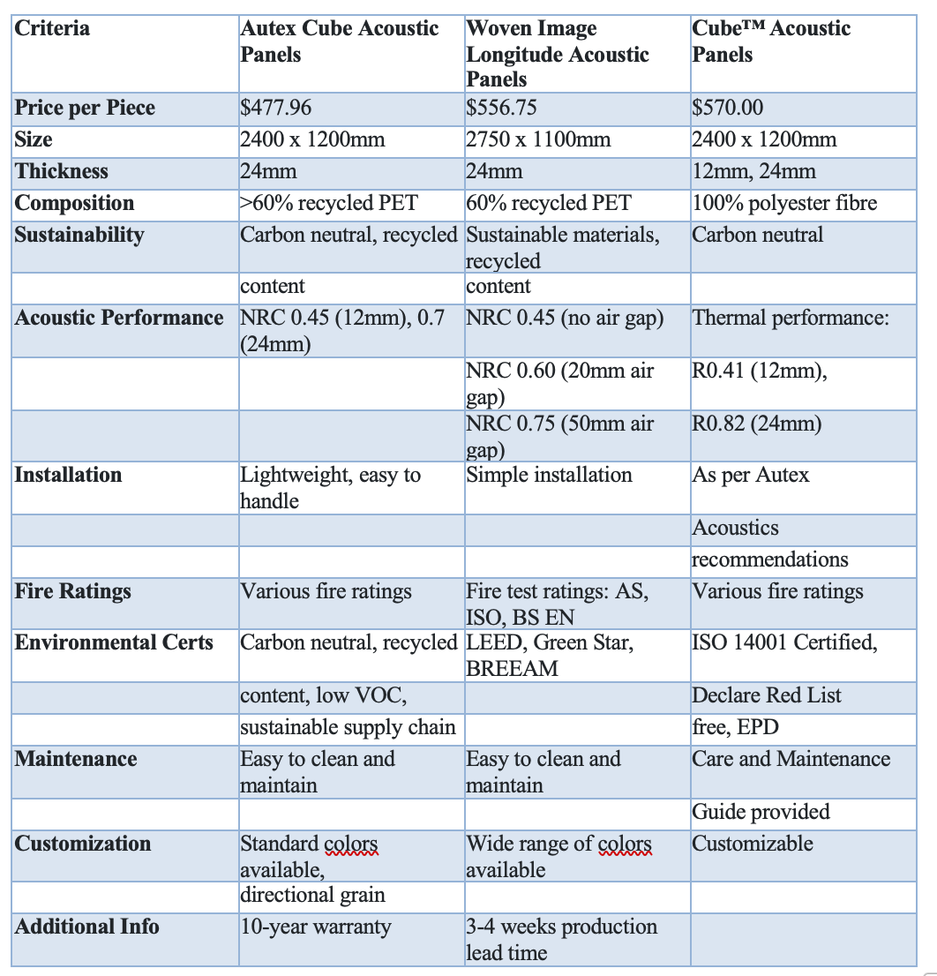

*Table 2 ; Comparison of Sound Panel Companies*

**Recommendation:**

Choose Woven Image Longitude Acoustic Panels for your VR sound space upgrade project. Here's why:

1. Acoustic Performance: These panels excel at reducing reverberated noise, crucial for enhancing the immersive VR experience.

2. Environmental Certifications: Woven Image panels hold certifications from green building rating systems like LEED, Green Star, and BREEAM, showcasing their commitment to sustainability and modern design trends.

3. Fire Ratings: They meet safety standards, ensuring reliability for interior applications.

4. Design Flexibility: With a wide range of stylish colors, these panels offer design flexibility, essential for creating an aesthetically pleasing VR sound space.

5. Ease of Maintenance: Simple to clean and maintain, these panels ensure long-term durability and aesthetics.

6. Free Shipping: The shipping of the sound panels is complimentary, courtesy of our bulk purchase from the local market.

7. Price: While slightly more expensive than Autex Cube panels, the additional features and benefits make them a worthwhile investment, especially for projects where acoustic performance is critical.

**VIVE Headset & controller Kit**

Twenty-Seven commercial Grade headsets and controllers are additionally included in the deliverables. Table below (Comparison of headsets) shows the comparison for 3 types of VIVE headsets as our chose brand as VIVE is CES 2023 best VR headset collections brand which we believe is best for SVP and team decided to choose VIVE Pro2 Kit upgraded commercial-grade virtual reality headsets and controllers covered by a comprehensive manufacturer's warranty. A Kit includes high-functioning next-level VIVE Pro 2 headset, link box, Display port cable, USB 3.0 cable, power adaptors, two Controllers (2018), two base stations 2.0, user guide, safety guide, and warranty card. The shipping fees are calculated as free of charge since the team is ordering 27 kits for SVP.

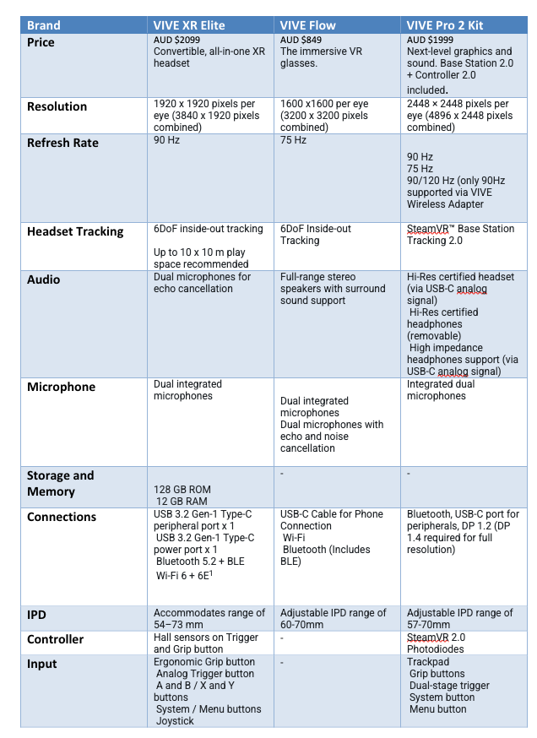

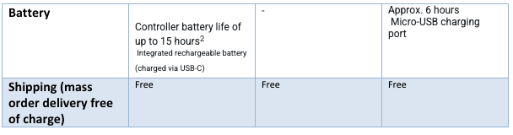

*Table 3; Comparison of products VIVE headset Brand*

**85” Ultra HD TV**

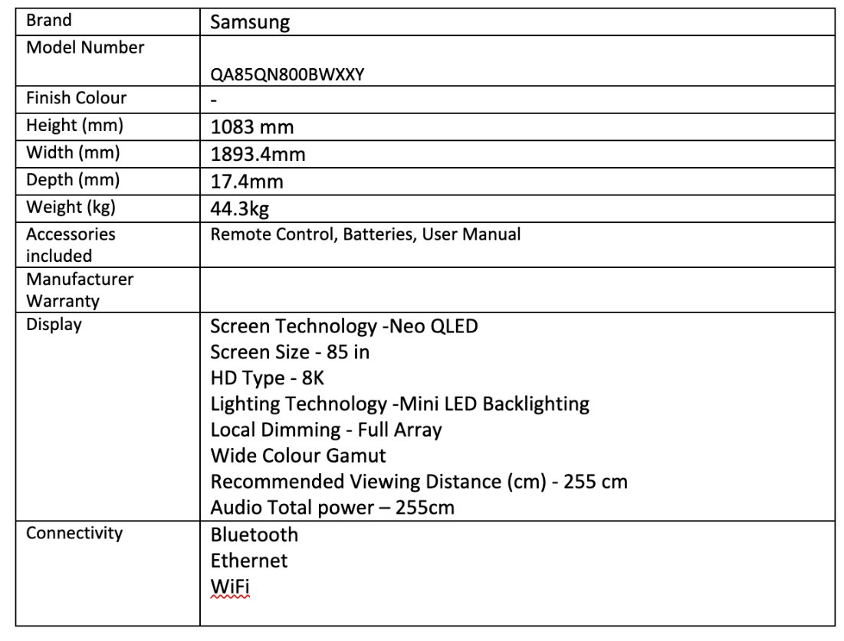

*Table 4: Detail Information of Samsung QN800B 85"Ultra HD 8K TV*

The Samsung QN800B brand TV was selected because this is the most cost-effective TV among the handfuls 8K 85” TVs, with sufficient requirements of the project after investigating with same sizes from well-known brands, and specific contrast (Table 3). Due to the reviews, Samsung QN800B is a 8K TV that boasts gaming capabilities, a comprehensive smart TV experience, fantastic audio, a third-party box for external inputs on the market. The fact that the product is the least expensive but having as many functions as possible when compared to other well-known brands in the industry is another reason to choose it. In addition, allowing users to accommodate in the waiting room and providing a better client experience. Therefore, the team opted to choose the Samsung QN800B brand 85” HD 8K TV as a result.

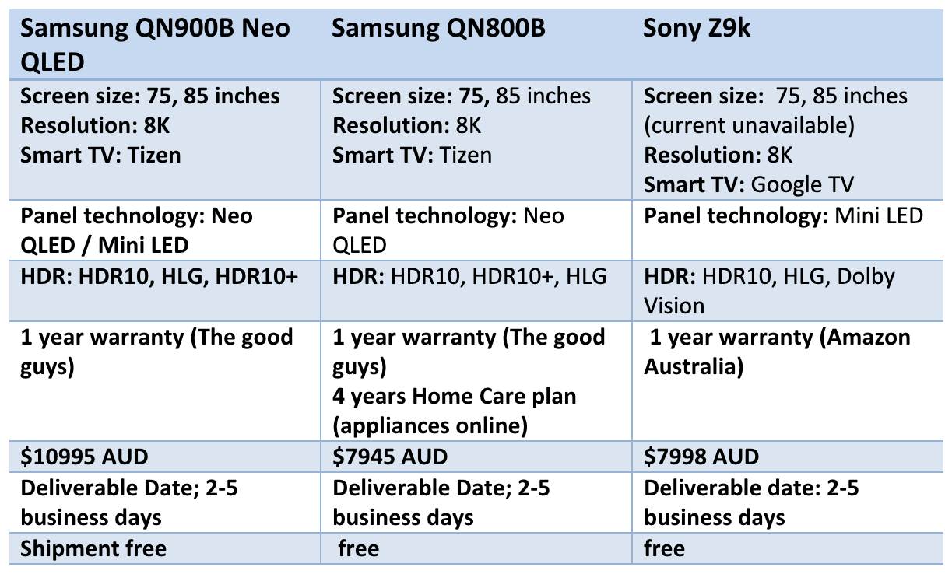

*Table 5: Comparison of 85’’ Ultra-HD TVs in the market*

**5.1 Wireless Speaker System**

The Samsung HW-Q800C/XY 5.1.2ch Dolby Atmos Soundbar is an integral component of the Supercharged VR Games (SVG) project. This soundbar offers a range of features and capabilities to enhance the audio experience for SVG's virtual reality gaming center. Thesoundbar was chosen for several reasons:

**Cost-Effectiveness:** Among the limited options for 5.1.2ch Dolby Atmos soundbars, the Samsung HW-Q800C/XY represents a cost-effective choice, meeting the project's requirements.

**Audio Quality and Capabilities:** The soundbar boasts the latest and true Dolby Atmos technology, ensuring an immersive audio experience for gamers. Its Q-Symphony feature enhances audio quality and immersion.

**Space Fit Sound Pro:** This technology helps optimize sound calibration within the gaming rooms, ensuring an ideal audio environment for players.

**Connectivity:** With multiple connectivity options, including HDMI, Bluetooth, and WiFi, the soundbar can easily integrate with SVG's equipment and systems.

This soundbar is designed to upgrade the audio experience for SVG's customers and complement their VR gaming offerings. It offers advanced sound features and connectivity options to enhance the immersive gaming experience.

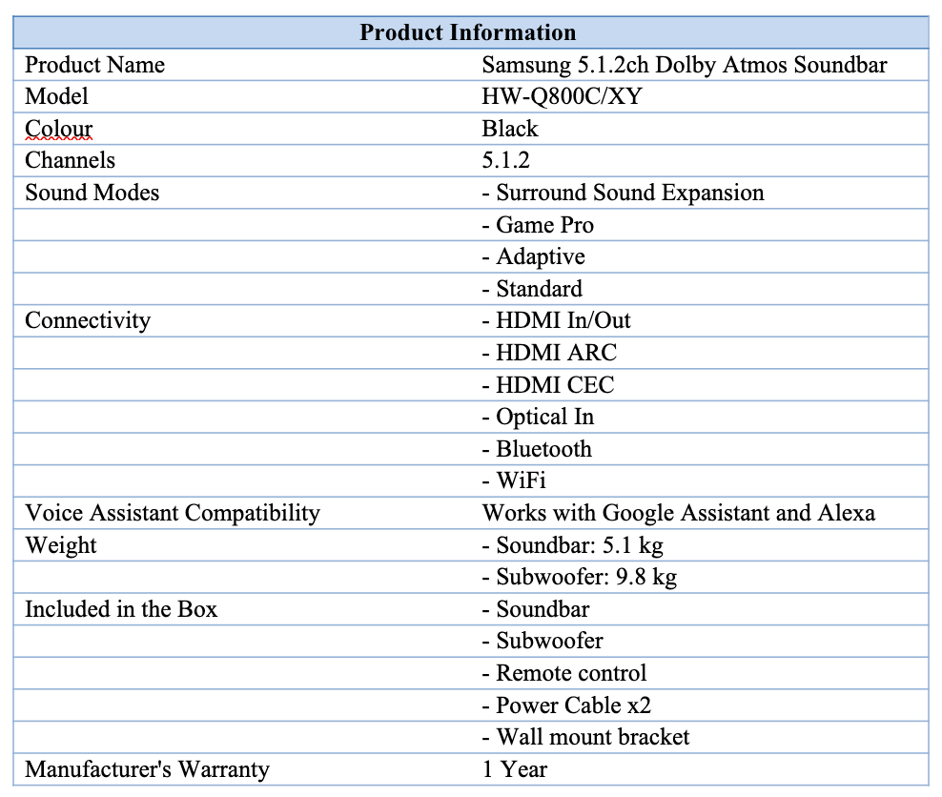

*Table 6 : Detail information of Samsung Dolby Atmos Soundbar*

# 4. Schedule

Project scheduling involves planning and organizing tasks and resources within a specified timeframe to ensure efficient project completion. It's a fundamental tool for project managers used to monitor and control progress. Task planning begins with the project's scope and key documents, involving stakeholders for diverse input. While not overly detailed, the schedule should flag issues. Task durations and dependencies are considered. *(Larson. 2020).* For our SVG project, we used MS Project for scheduling.

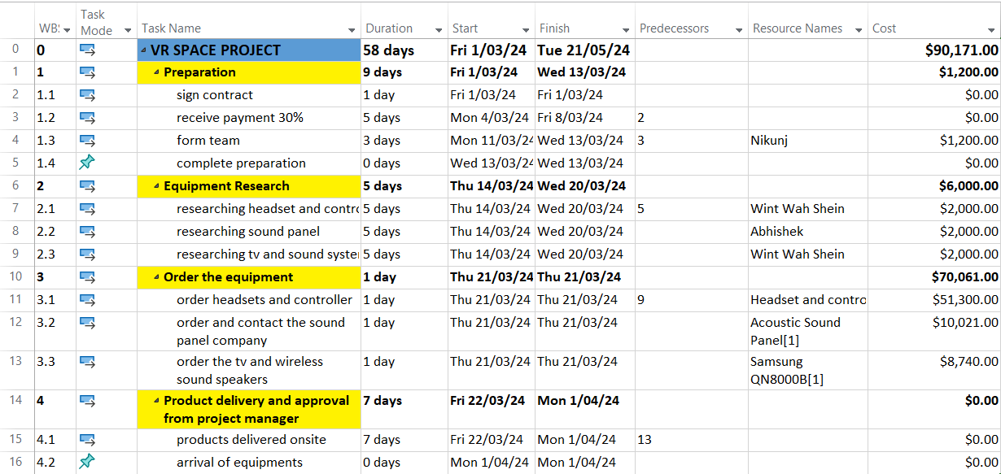

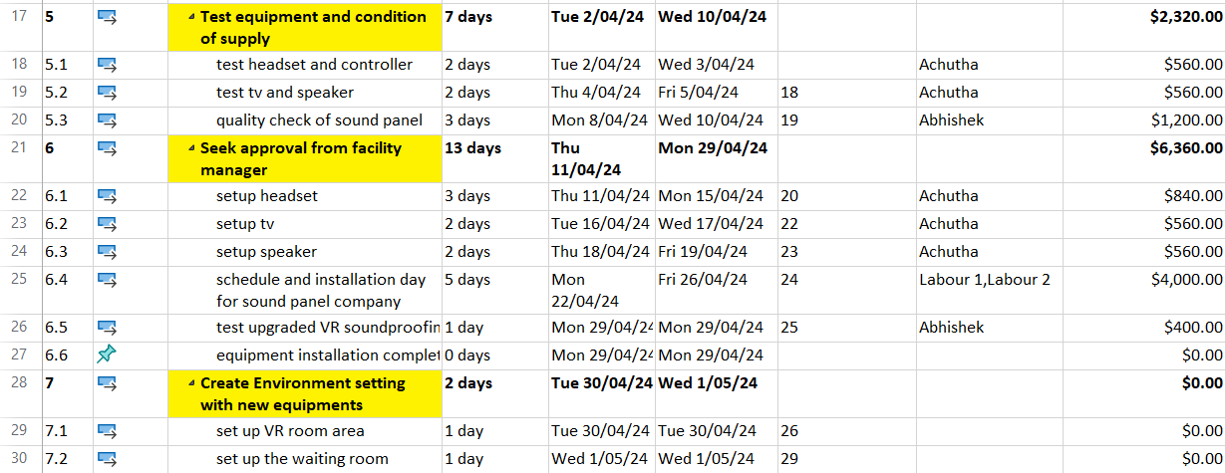

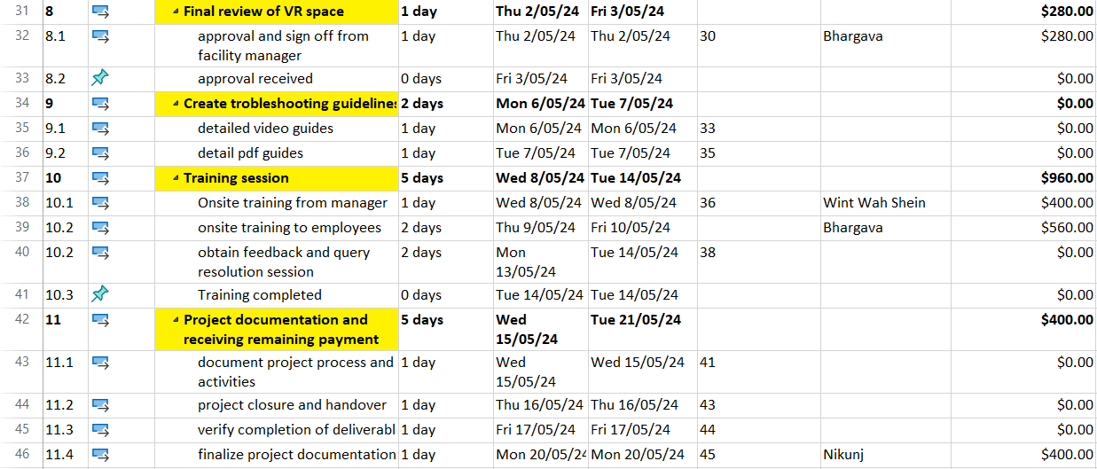

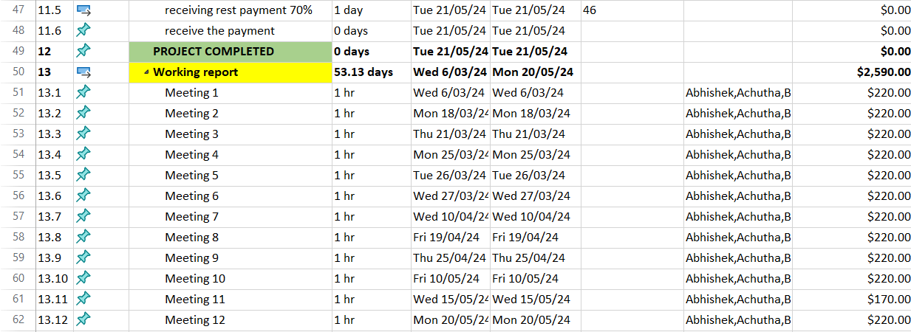

**GANTT CHART**

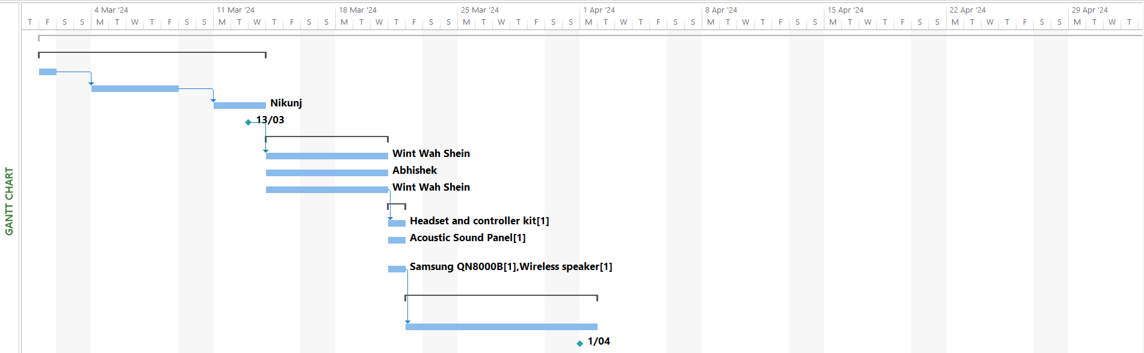

`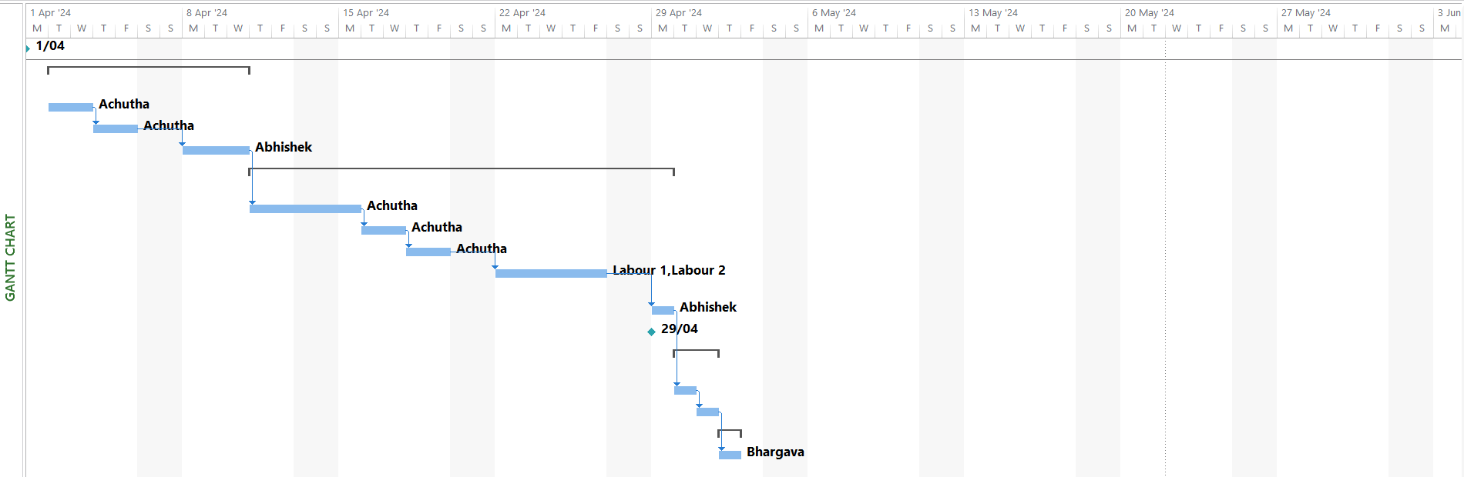

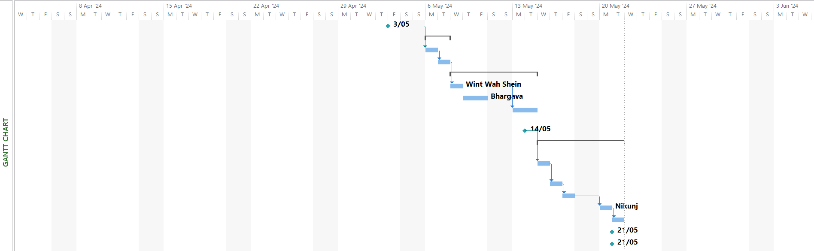

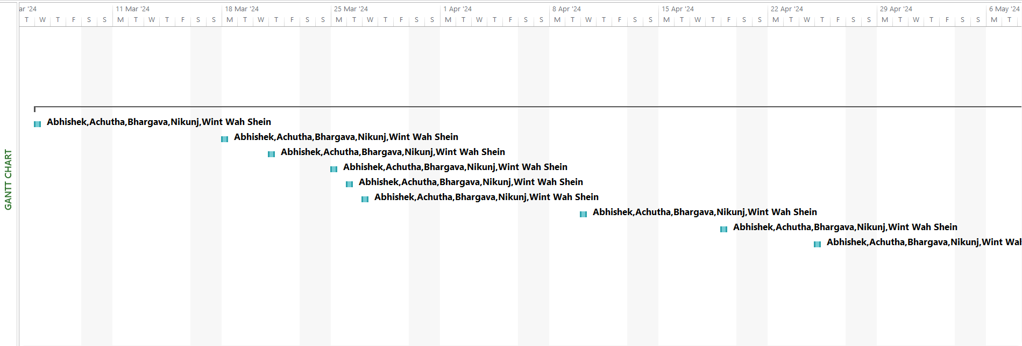

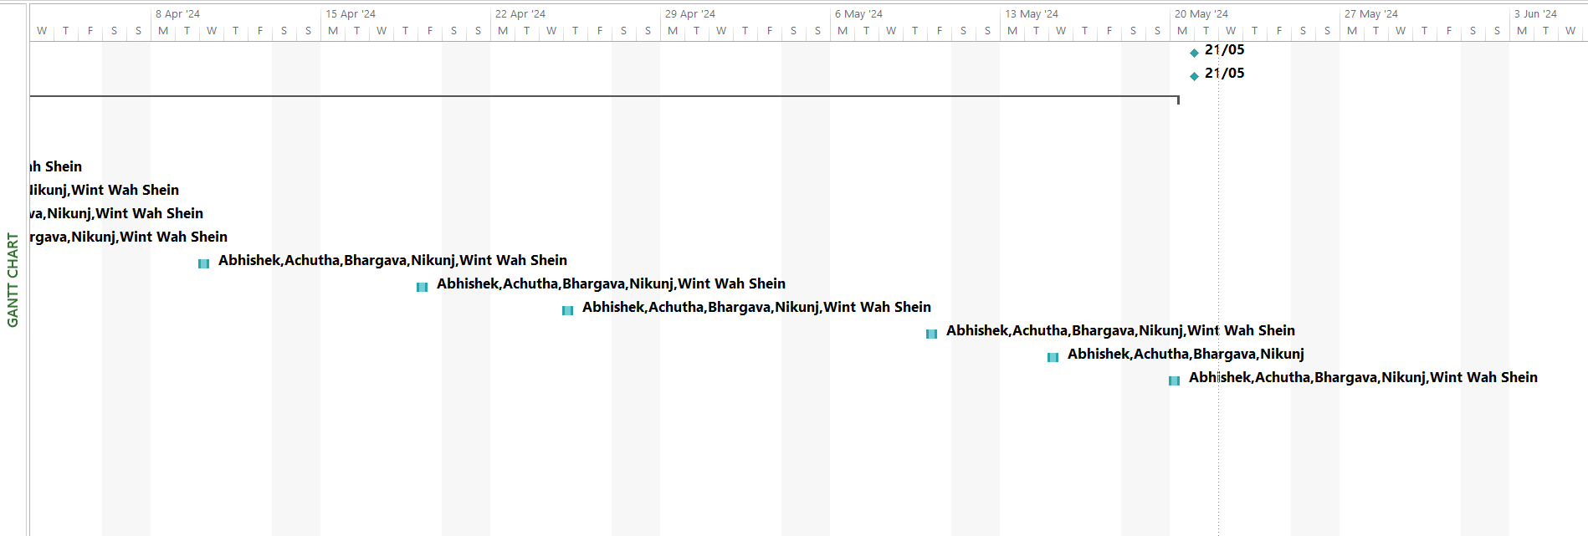

**Milestones**

1. Project preparations work completed on March 13, 2024.
2. Equipment arrived at site on March 28, 2024.
3. Equipment installation completed on April 29, 2024.
4. Approved from the facility manager on May 3, 2024.
5. Completed training session on May 14, 2024.
6. Received the rest payment for the project on May 21, 2024.
7. Completed the project May 21, 2024.

The project will be divided into twelve steps, with Milestones specified at each stage:

**1: Work on Preparation**

The figure shows how the team begins the project on March 1, 2024, enters a contract with SVP, and allocates duties to every team member after obtaining 30 percent deposit in advance. The preparations will take nine days to complete.

**2: Researching equipment**

The team will allocate two employees to find the companies and equipment needed to fulfil the project's specifications in five days beginning on March 14, 2024, and will make a final decision after weighing cost and performance. The research will take 5 days.

**3: Order the Equipment**

Once the manager approves the supplies order, the team member puts the order on March 21, 2024, and awaits delivery from the supplier. It takes one day to complete the order.

**4: Product Delivery and Approval**

The manufacturer notified the crew prior to prepare for the arrival of the items. After the equipment's were delivered, it was verified on the premises for accuracy to confirm that all components fit the standards before being moved into the spaces. It will take up to 7 days till April 1, 2024, to wait for shipment, acquire, and verify the equipment.

**5: Test equipment and condition of supply**

Upon supply receipt, the IT team has 7 days until April 10, 2024, to test devices and prepare. After supplies arrive, they will promptly measure and schedule the installation of sound panels. The panel setup in the three VR rooms will take four days by the sound panel company's employees.

**6: Seek approval from manager**

This step will conclude on April 29, 2024, taking a total of 13 days. Following facility manager approval, the equipment installation will be completed within 7 days. The installation of sound panels will span 5 days, followed by a final day for testing the upgraded soundproofing rooms.

**7: Create environment settings**

After completing testing equipment, the team will set up the environment setting on May 1, 2024 and this step will be planned to spend 2 days to finish. Check the operation of the equipments and installation of sound panels.

This phase includes figuring out whether the equipments will function properly. After installing everything, clean the rooms, change the layout, and create a new upgraded environment setting before getting reviewed by the onsite manager.

**8: Final Review of VR space**

The review will be done by the facility manager and signed off on May 3, 2024.

**9: Create troubleshooting guidelines**

The quick guides for equipment and IT troubleshooting are made in this step starting on 6 May 2024 and takes two days. It plans to take a total of one day for designing the video guide for equipment and designing the PDF guide, troubleshooting in one day for the client.

**10: Training session**

The actual deliverables of the project will happen at this step and will also result in a Milestone by completing training for the customer's IT staff and users from May 7, 2024, to May 14, 2024. The onsite training of managers plus 12 VR hosts will be given one day, onsite training to employees by training manager will be give total two days. After these days, the training leader will obtain feedback and make resolution session which will go for two constant days.

**11: Project Closure, Documentation and receive payment**

The project will be completed on 21st May 2024 and generate a Milestone on step 12, after receiving the final payment.

**12. Project Completion**

# 5. WBS Dictionary

The WBS code, task label, and comprehensive description of the task are all contained in this WBS dictionary (Latief et al., 2019), as illustrated in Table, with the task summary providing a detailed explanation of the procedures involved in each task. Project managers use the WBS lexicon as a reference to comprehend, oversee, and alter projects. 1.4, 4.2, 5.4, 7.2, 9.3, and 10.6 are Milestones in the WBS scheduling and they are not documented in the below WBS dictionary description section.

|  |  |  |
| --- | --- | --- |
| WBS Code | Task name | Description |
| 1.1 | Sign Contract | Start project. Browse the contract to identify contract details. Sign the contract with SVG. |
| 1.2 | Receive the 30% payment | Accept payments from SVG. |
|
| 1.3 | Form Team | After project planning and payment are done, start from the team. |
| 2.1 | Search Headsets and controllers | Research and compile a list of suitable VR headset models. Compare the costs between various retailers. The model with the best cost performance should be chosen. |
| 2.2 | Search Acoustic sound panels company and Speaker | Acquire sound panels for soundproofing the rooms. Compare the costs between various sound panel companies and the ability to install by the company or not. |
| 2.3 | Search 85-inch 8K TV Search Wireless 5.1 Surround Sound System | Investigate the specified TV for the home theatre system. Compare the costs between various retailers. The model with the best cost performance should be chosen. Search for the best wireless 5.1 home theatre sound system on the market. |
|
| 3.1 | Order Headsets and controllers | Pay in person or online. Inform the retailer of the shipment address and date. |
| 3.2 | Order and contact the sound panel company | Pay in person or online. Inform the company of the shipment address and date and schedule for installations. |
| 3.3 | Order the TV and speaker wireless system | Pay in person or online. Inform the retailer of the shipment address and date. |
|  |  | Receive a call from the delivery service. Obtain the equipment at the appointed time and location. |
| 4.1 | Products are delivered to SVG onsite. | Receive, check, and accept the items onsite once delivered. Verify the integrity of packages. Suggest the Demonstration and set up the tools in the room. |
| 5.1 | Test the functionality of the headsets and controllers | Turn on the power and test the system and software operating situation. Check whether the |
|  | VR headsets and controllers work well with the existing software. |
| 5.2 | Test the functionality of the TV and speaker system | Turn on the power and test the system and software operating situation. Check whether the software is updated to the latest version and whether all the software required by the customer has been installed. |
|  | Turn on the speaker power and test whether it works with the 8K TV. |
| 5.3 | Quality check of Sound panel | Conduct a quality check on the sound panel to verify compliance with set standards and identify any defects or performance issues. Record and report findings for potential corrective action. |
| 6.1 | Set Up Headsets | Unpack the package. Connect the headsets to the VR spaces. |
| 6.2 | Set Up TV | Open the package, connect the hardware, install the operating system and other applications required for TV support, and then unpack it. |
| 6.3 | Set Up Speaker | Connect the TV and speaker |
| 6.4 | Schedule the installation day for Sound Panels company for VR spaces. | As soon as the supplies arrive, the installation team will come and measure the VR spaces. Schedule them next business days to set the panels up. Set up sound panels in each of the three VR rooms which will take two days. |
| 6.5 | Test the Upgraded VR rooms soundproofing | Check the VR spaces if they are soundproof or not by playing their existing games and doing some sound testings. |
|
| 7.1 | Set Up the VR room area after the installation | After Installation, Clean the floor and everything. Put headsets and controllers inside. |
| 7.2 | Set Up the waiting room environment setting | After setting up the TV and speaker, put the interior decor etc coffee machine, water dispenser, a plant, and chairs, make it look more aesthetic. |
| 8.1 | Obtain Final approval and Sign-off from Facility Manager | Receive formal approval from the Facilities Manager. |
| 9 | Create troubleshooting guidelines | Create the guidelines for troubleshoot common issues. |
|
| 9.1 | Detailed video guides | Produce instructional videos for using the gaming equipment's and home theatre system. Prepare the video for clear instructions. |
|
| 9.2 | Detailed pdf guides | Create a single PDF manual explaining how to use the headsets, TVs and speaker system. Plus, the sound panel company will give a maintenance pdf files for sound panels. Another PDF on managing common troubleshooting for the IT assistance team. |

# 6. Resources

The resource sheet contains 12 vital resources whose primary objective is to aid in the execution of the project. All the resources are organised into distinct groups. The project involves five employees, the cost of which is determined by the amount of time spent. Nik is the team's manager, in charge of determining and overseeing the project's general development direction. Abhishek leads the IT team and collaborates with Achutha on all IT-related tasks. Wint is the training leader and works with Bhargava to oversee the training. Managers and Team Leads are paid $50.00 per hour, while team members are paid $35.00 per hour. There are 5 material resources which are calculated based on the quantity utilised. Headset & controller kits are required to set up the VR room and cost $51300 for all kits. The TV and speaker are required for home theatre set up and cost $7945 and $795 respectively. Acoustic Sound Panels cost $10,021 for 3 VR rooms which is 170 sq ft each room. The installation of Sound Panels is done by the chosen panel company for three VR rooms, the cost is $4000 which is charged $100 per hour (50*2) for 2 labours for 5 days. For this information, we contacted the chosen company for installation fees during the preparation stage.

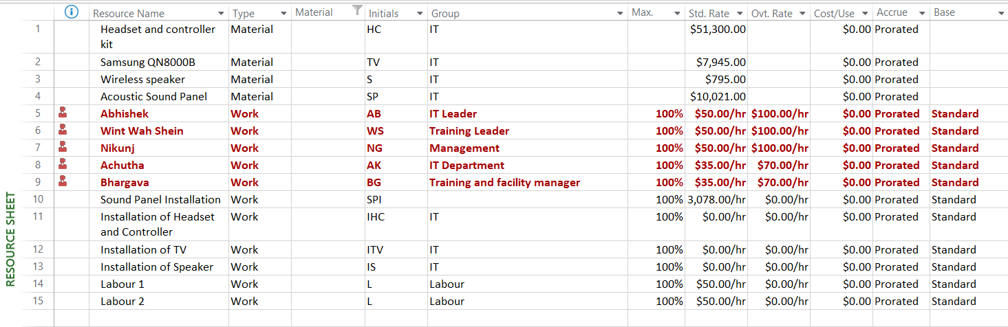

# 7.Cost

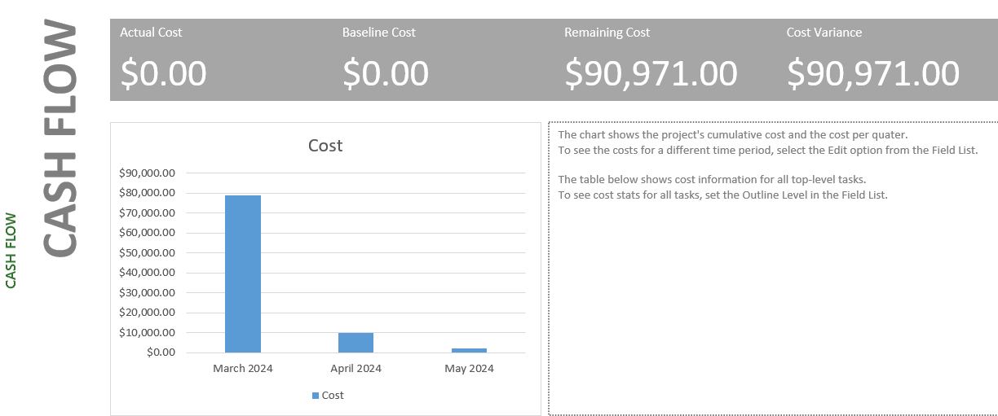

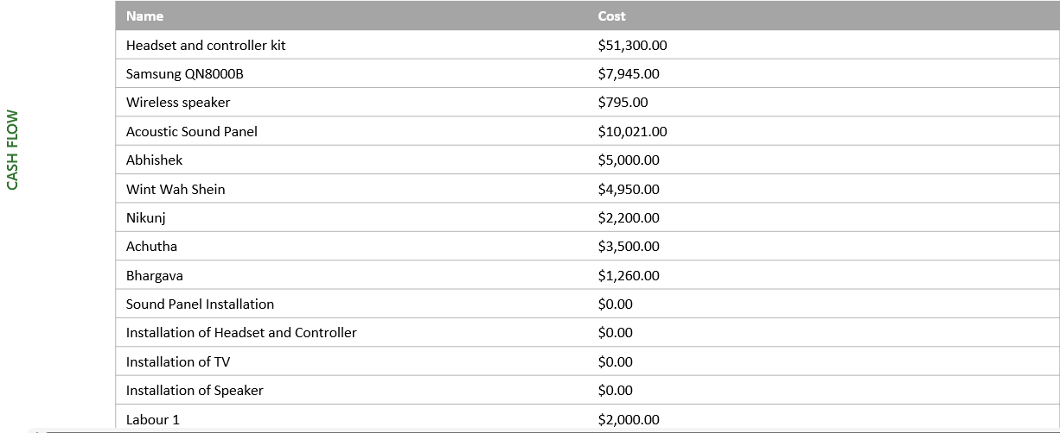

There are three sorts of resources (cost sources) in this project. The initial cost is the costs of tangible items such as headset & controllers, TV and speaker system. The second is resource costs (human resources), employee pay, which has been calculated based on hours worked. Employees must engage in all project activities. As a result, this intake is essential. The hours spent working in this project have been estimated using regular working days, but the actual working time will be substantially less, hence the actual cost will be much lower than the anticipated cost. The third is the cost of labour for installing the sound panels by the sound panel company during the project.

# 8.Risk

It is unavoidable that team may confront unexpected obstacles throughout its implementation. Those are also occasionally referred as risk factors (Kendrick, 2015). It is critical to foresee and handle risks throughout the project proceeds.

**Risk Identification**

As shown in the figure, The RBS explains about the different risks which may arise in the project.

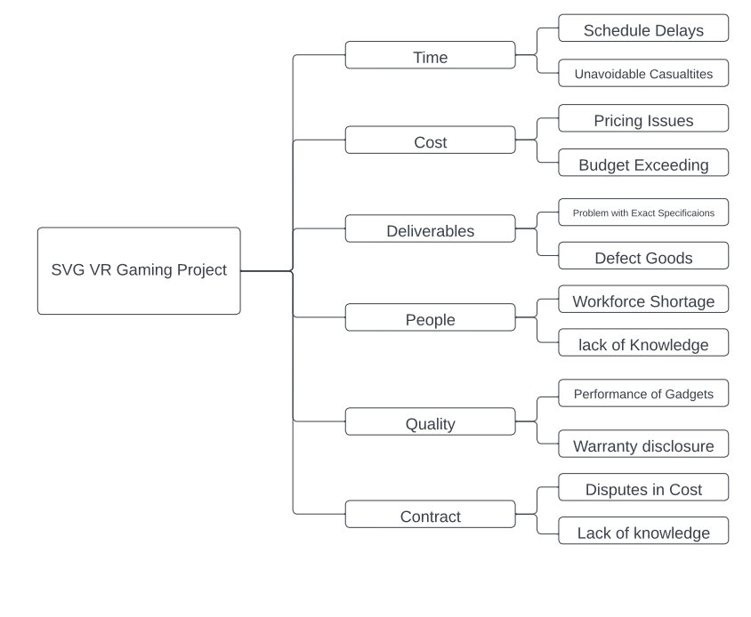

Risk Breakdown Structure of SVP Project

**Risk Assessment**

The project is evaluated for potential risks based on the severity of the impact, the chance of the risk occurring, and the challenge of finding the risk. Table below depicts the intensity of each potential risk's adverse effect. 1 to 5 represent a range from low to high.

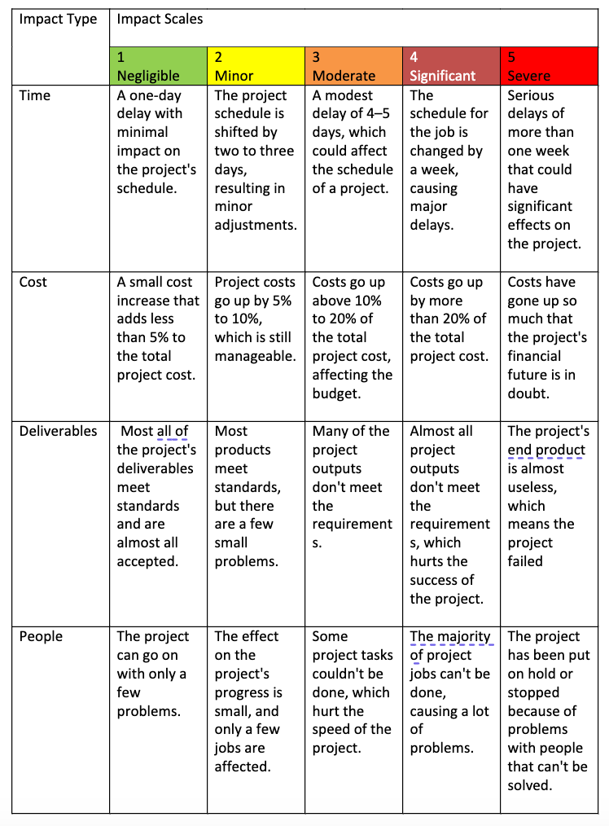

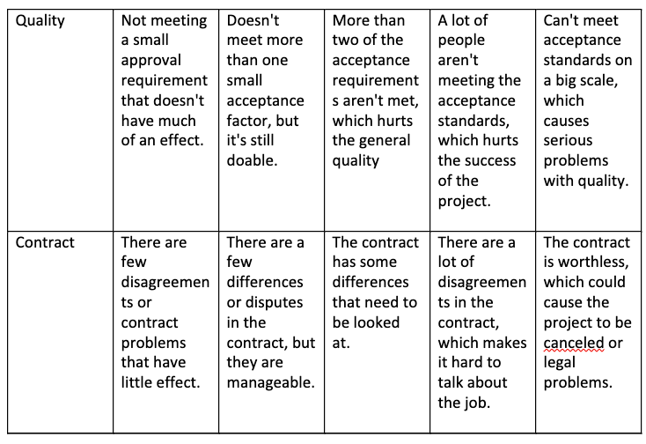

Table ; Defining Factors for Risk Impact Scales on RFP Project

**Risk Assessment Form**

The risk assessment form is shown in Table below. The values ranging from 1 to 5 in the detection challenge column show the difficulty of discovering a danger before it has a negative impact. Our risk assessment also includes Risk Value which is Impact × Probability × Detection.

|  |  |  |  |  |  |  |
| --- | --- | --- | --- | --- | --- | --- |
| **Risk Event** | | **Likelihood (Probability)** | **Impact** | **Detection Difficulty** | **When** | **Risk Value** |
| 1 | Delays in delivery/ extended ETA | 3 | 3 | 3 | Delivery of Goods | 27 |
| 2 | Increase in Prices Materials (headsets, controllers, TV, speaker, sound panel) | 2 | 3 | 4 | After the items research process and before the buying process | 24 |
| 3 | Some of the materials not meet quality standards | 3 | 4 | 4 | During the Delivery Process of materials | 48 |
| 4 | Materials got rejected by facility manager | 2 | 5 | 4 | During Approval | 40 |
| 5 | Sound Panel Company' s employees exhibit skill inadequacies when installing panel in VR rooms. | 1 | 5 | 3 | During Installing sound panels | 15 |
| 6 | RFP’s building manager dislike the chosen sound panels and home theatre set up. | 1 | 4 | 4 | After Delivery and installation | 16 |
| 7 | Defective performance of products in VR rooms. | 1 | 5 | 2 | During training session | 10 |
| 8 | Contract for a disputed project | 1 | 5 | 5 | Before wrapping up the contract | 25 |

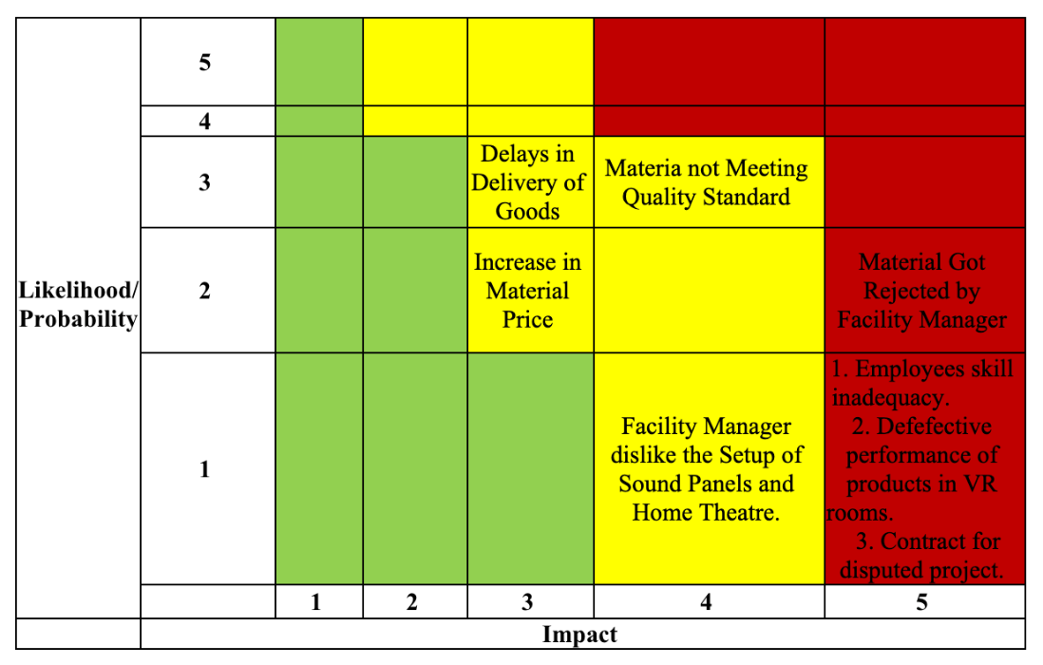

*Table: Risk Severity Matrix of SVP project*

# Risk response matrix

The Table below shows that in terms of Response- Team's reaction to the project's risk occurrence. When a risk happens, the contingency plan provides an alternate solution. The trigger in our case is a stage in the completion of the project, failing to follow tasks might result in a risk.

|  |  |  |  |  |
| --- | --- | --- | --- | --- |
| **Risk Event** | **Response** | **Contingency Plan** | **Trigger** | **Who is Responsible?** |
| Delays in delivery/ extended ETA | Risk Reduction: Notify the manufacturer of the shipping date well in advance. | In progress, research the things to be purchased offline and make purchases in real stores. | There was no thorough communication with the supplier regarding delivery dates. | Wint Wah Shein |
|  |
| Increase in Prices Materials (headsets, controllers, Tv, speaker, sound panel) | Risk reduction: Arrange an alternative brand in advance | Schedule replacement. | Not analysing prices frequently throughout the purchasing and payment procedures. | Abhishek |  |
| Wint |  |
| Some of the materials not meeting quality standards | Identify non-compliant materials, communicate with the supplier for replacement, and conduct quality rechecks. | Utilize alternative suppliers, if necessary, to expedite replacement. | Discovery of non-compliant materials. | Wint |  |
| Abhishek |  |
| Materials got rejected by facility manager | Risk reduction: Initial testing prior presenting to RFP facility managers | Request an alternative from the vendor. | There has been no previous test. | Nik |  |
|  |
| Sound Panel Company' s employees exhibit skill inadequacies when installing panel in VR rooms. | Risk reduction: remind the Sound panel company to sufficient staff training for VR rooms. | Request assistance from other experienced employees inside the company. | No double checking with the chosen company’s inadequate training of employees and company’s reviews | Abhishek |  |
|  |
| RFP’s building manager dislike the chosen sound panels and home theatre set up. | Engage in dialogue with the building manager to understand concerns, explore alternative solutions, and seek mutual agreement. | Consider alternative sound panel and home theatre options in collaboration with the building manager. | Building manager expresses dissatisfaction. | Abhishek |  |
|  |
| Defective performance of products in VR rooms. | Promptly address technical issues through troubleshooting and supplier support, ensuring minimal downtime. | Maintain a technical support team and have contingency equipment available for replacement. | Identification of performance issues. | Abhishek |  |
| Wint |  |
| Contract for a disputed project | Engage in dispute resolution procedures outlined in the contract, involving legal counsel if necessary. | Prepare for possible legal actions, arbitration, or mediation as outlined in the contract terms. | Dispute arising from the project. | Nik |  |
|  |

# 9. Stakeholders

A stakeholder analysis is a project management tool used to identify and understand the people or groups affected by a project, their needs, and how they might influence or be influenced by the project. It helps in effective communication and managing conflicting interests. The process involves gathering, and analyzing stakeholder information, and creating a stakeholder map to determine communication levels. Stakeholder analysis can reveal conflicts and help adjust the project scope before it starts. (Hoory L; Bottorff C. 2022). In our Supercharged VR Games project, we have successfully identified the stakeholders and evaluated their levels of interest and influence. Furthermore, we have developed a stakeholder analysis table and strategically placed the stakeholders on the Power-Interest Grid. Lastly, we have incorporated a quadrant chart visualization for enhanced clarity.

**Identify Stakeholders**

**List of stakeholders:**

1. Project Management Team
2. SVG Staff (Facility Manager and VR Hosts)
3. SVG Customers
4. Neighbouring Tenants
5. Supplier/Contractor
6. Regulatory Authorities
7. Competitors in VR Gaming Industry
8. Investors/Shareholders
9. Bank and Financial Institutions
10. Local Community
11. Government Authorities
12. Media and Public Opinion
13. Environmental Advocacy Groups
14. Contract Review Team

**Stakeholder Analysis Table**

|  |  |  |  |
| --- | --- | --- | --- |
| **Stakeholder** | **Interest/Concerns** | **Influence/Power** | **Potential Impact** |
| Project Management Team | Project success, customer satisfaction, profitability | High | Direct control over project, funding decisions |
| SVG Staff (Facility Manager and VR Hosts) | Successful training, ease of equipment operation | Moderate | Direct involvement in operations |
| SVG Customers | Quality of VR experiences, comfort, and satisfaction | Moderate | Can impact revenue and reputation |
| Neighbouring Tenants | Noise reduction, improved relations | Moderate | May affect SVG's ability to operate |
| Supplier/Contractor | Delivery of quality goods and services, timeline adherence | High | Direct impact on project execution |
| Regulatory Authorities | Legal compliance, safety standards | High | Can halt or delay the project |
| Competitors in VR Gaming Industry | Industry changes, competitive landscape | Moderate | May adapt their strategies |
| Building Manager | Low | High | Requests soundproofing upgrade; Approves equipment |
| Facilities Manager | Low | High | Approves equipment after product demonstration |
| Investors/Shareholders | Financial implications, ROI | High | May influence funding decisions |
| Bank and Financial Institutions | Ensuring payment according to contract terms. | Moderate | May influence Financing of the Project |
| Local Community | Noise concerns, perception of SVG | Low | Can affect public perception |
| Government Authorities | Permits, compliance with regulations | High | Can halt or delay the project |
| Media and Public Opinion | Public perception, potential controversies | Moderate | Can shape public opinion |
| Environmental Advocacy Groups | Use of environmentally friendly materials | Low | May highlight sustainability efforts |
| Contract Review Team | Contract terms, milestones, penalties | Moderate | Approves contract and payment terms |

*Table; Stakeholder Analysis of SVG project*

**Assess Stakeholder Interest and Power**

Below is an assessment of each stakeholder's level of interest (High or Low) and power (High or Low) based on the provided information:

**High Power, High Interest:**

* SVG Management
* Supplier/Contractor
* Regulatory Authorities
* Investors/Shareholders
* Government Authorities

**Low Power, High Interest:**

* SVG Customer
* Competitors in VR Gaming Industry
* Media and Public Opinion

**High Power, Low Interest:**

* Building Manager
* Facilities Manager

**Low Power, Low Interest:**

* SVG Staff (Facility Manager and VR Hosts)
* Local Community
* Environmental Advocacy Groups
* Contract Review Team

**Position Stakeholders on the Power-Interest Grid**

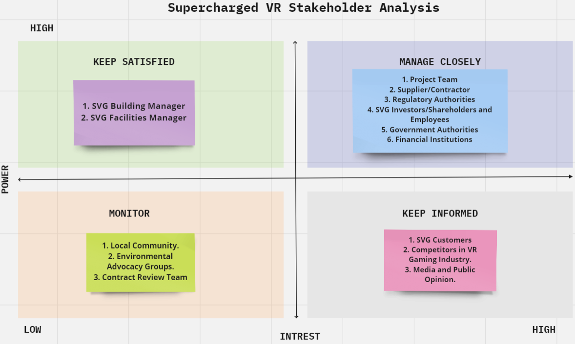

# References

“Autex Cube Acoustic Panels - Acoustic Sound Products Gold Coast.” (2023). *Acoustic Sound Products,* 23 Aug. 2023, [<Link>](https://acousticsoundproducts.com.au/product/cube-acoustic-panels/) Accessed 29 Sept. 2023.

Hoory L; Bottorff C (2022) *What is a stakeholder analysis?* Everything you need to know, Forbes Advisor [<Link>](https://www.forbes.com/advisor/business/what-is-stakeholder-analysis)

Kendrick, T. (2015). *Identifying and managing project risk: essential tools for failure-proofing your project.* Amacom.

Larson, E. (2020). *Project Management (8th ed.).* McGraw-Hill US Higher Ed ISE.

Latief et al. (2019). Development of work breakdown structure (WBS) dictionary for the construction works of lower structure steel bridge. In MATEC *Web of Conferences* (Vol. 258, p. 02003). EDP Sciences.

Samsung AU (2023). Samsung Australia. [online] *Samsung AU*. Available at: [<Link>](https://www.samsung.com/au/).

VIVE. (2023). VIVE Products - Compare Models | *VIVE Australia.* [online] Available at: [<Link>](https://www.vive.com/au/product-comparison/)

‌